

**PROJECT PLAN AND SECOND INCREMENT REPORT**

**SPRING 2017**



**Team – 1  
 Nageswara, Rao Nandigam – 61  
 Chakilam, Revanth – 9**

**Syed, Moin – 86**

**Sarda, Devender – 82**

**Table of Contents**

1. Project Goals and Objectives……………………………………………………….3
2. Project Plan and Management…………………………………………………… 4
3. Project timeline and responsibility………………………………………………6
4. Functionality Report……………………………………………………………………8
   1. WireFrames………………………………………………………………………..9
   2. Architecture Diagram………………………………………………………..15
   3. Class Diagram……………………………………………………………………15
   4. Sequence Diagram…………………………………………………………….16
   5. Use case Diagram……………………………………………………………..17
   6. Unit Test Cases………………………………………………………………….18
   7. Deployment………………………………………………………………………19
   8. Project Management………………………………………………………..24
5. Bibliography………………………………………………………………………………26
6. **Project Goals and Objectives**

**Motivation:** In today’s busy-busy world, it’s hard to stay fit and keep track of what we should eat and what we shouldn’t. With this underlying motivation, we came up with an idea to create an application which helps you do just that. Stay fit by keeping track of your eating habits and exercise routines.

**Significance:** Though we have multiple applications on fitness and nutrition in the market place, this application stands out as it combines both the dietary plan and exercise routine which a user can follow to make a healthy living and also we have put image recognition functionality which is not available in many of the applications today.

**The Objective:** The objective of this application is to make people fit and make them follow a diet for a healthy lifestyle.

**System Features:**

1. Register & Sign Up Option.
2. Create a plan for individual user.
   1. We will take weight and height of the user while doing registration and set target for day, week and month.
3. Track user calories based on Food + Exercise = Total Calories.
4. Display user progress with intuitive graphs and charts.
5. Image Recognition: User can upload images of food item’s he/she consumes, and our application calculates the approximate calories based on the image and food.
6. Exercise
   1. User has an option to select different exercises and enter inputs to track calories burned.
7. Pie chart
   1. You will have pie chart that for calories from meals. i.e. Breakfast, lunch and dinner.
8. **Project Plan and Management**
9. **Project Plan:** Schedule for the whole project is created

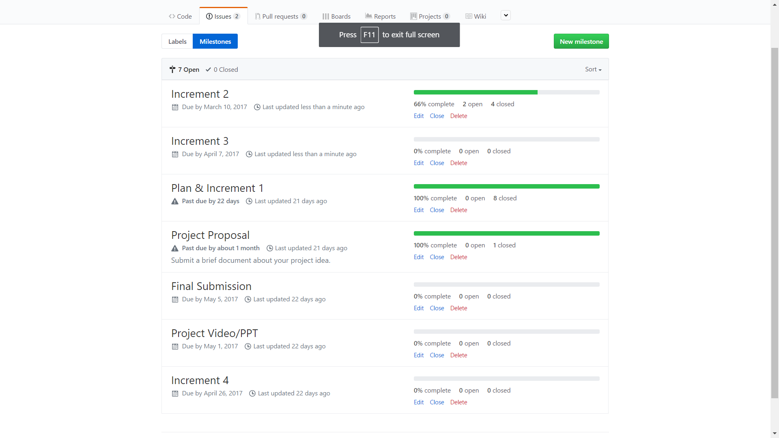

1. **Tasks and Issues Screenshot:**

These are the issues that describe the tasks with contributors allocated on each and every tasks. It is assigned with the level of difficulty and the tasks are successfully closed as they are completed.

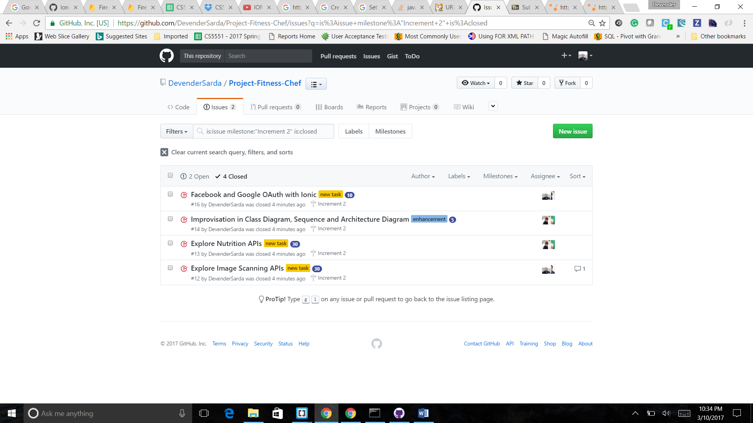

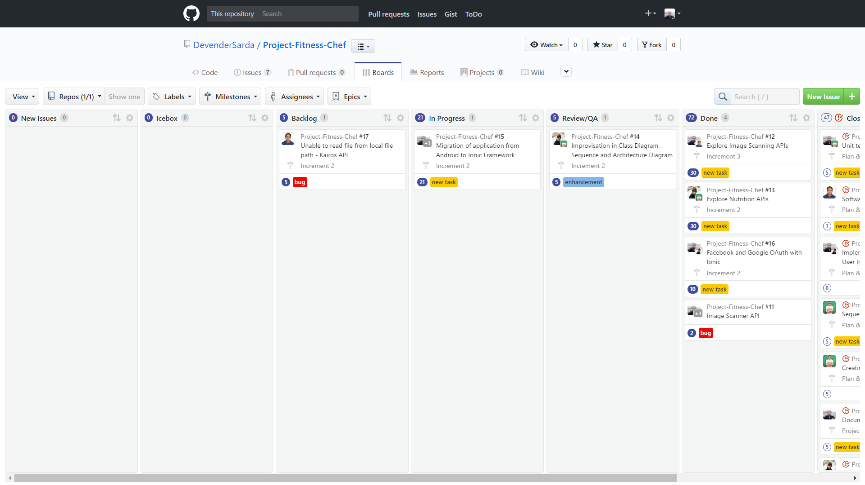

1. **Project Timelines and Task Responsibility**

**3.2.1 Project Timelines**

The Project is submitted in 4 increments and the aim is to achieve the said goals and tasks reported in the project

**3.2.2 Members**

• Nageswara Rao Nandigam

• Syed Moin

• Revanth Chakilam

• Devender Sarda

**3.2.3 Task Responsibility**

Each member has their own task and projected with limited timeline. Nageswara Rao Nandigam explored Kairos API, involved in migration of code to ionic framework, improved Sequence Diagram and helped in documentation & unit testing of the application. Devender was involved in migration of code to ionic framework, exploring Image scanning APIs like Google Cloud Platform API, integrated Google OAuth, involved in project management and unit testing. Syed Moin was involved in migration of code to ionic framework, exploring Nurtition APIs like NurtitionIX API, implemented Facebook OAuth, improved Architecture Diagram and unit testing. Revanth Chakilam majorly involved in styling and designing of the application, created html and css files for login, register pages, exploring APIs for the application, improved class diagram and helped in unit testing of application.

1. **Burn Down Chart**

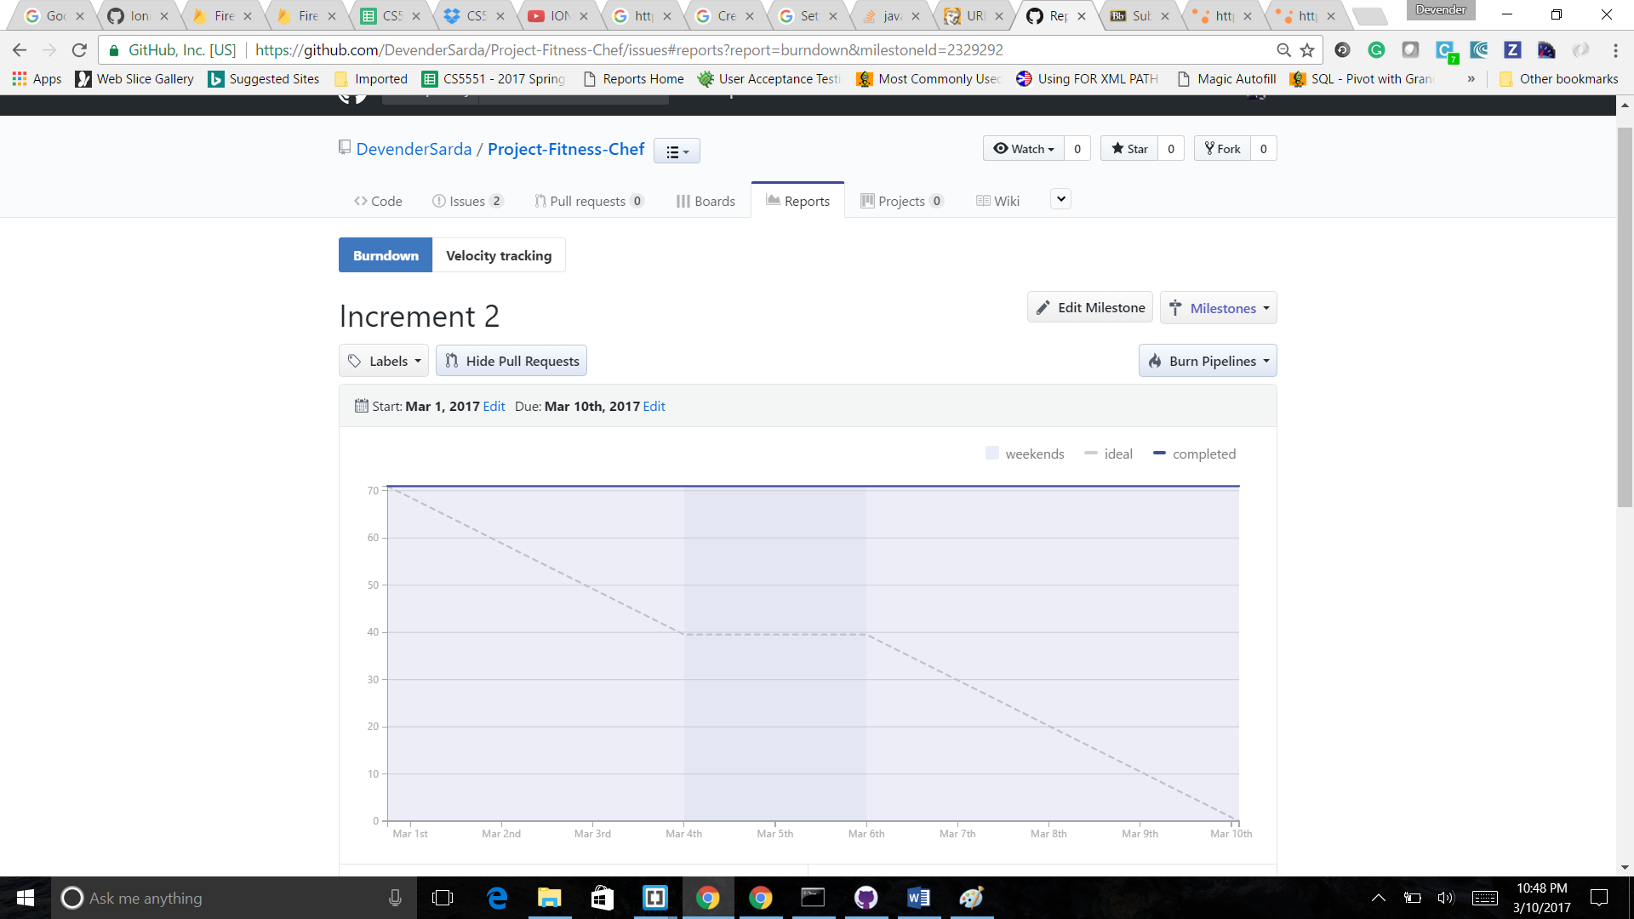

**4. Functionality Report**

The Project fitness chef mostly focusses on the nutrition and health benefits.

In the first increment, we have designed the pages main, login, signup, goal, details etc.

The user having an account can login directly. New Users has the facility to sign up in to the application. The new users can create an account based on the personal email id or through the social network O authentication. End users are provided with a choice to select the O authentication using either face book or google mail. Once the user connects to the application. He/she should set a goal whether to gain the weight or lose the weight or maintain the stability.

The users are asked with their height and weight in order to calculate the amount of calories intake and suggest them optimum nutrition for the betterment of their health.

In the details section, the users are asked to provide the personal details including location and date of birth.

* 1. **Existing Services/ REST API:**
* Facebook OAuth API
* Google OAuth API
* Android studio framework
* Local Storage
  1. **Detail Design of Features:**
     1. **Wireframes and Mockups**

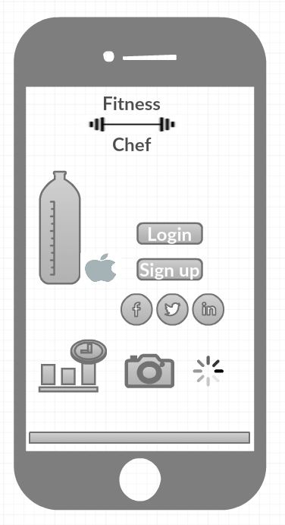

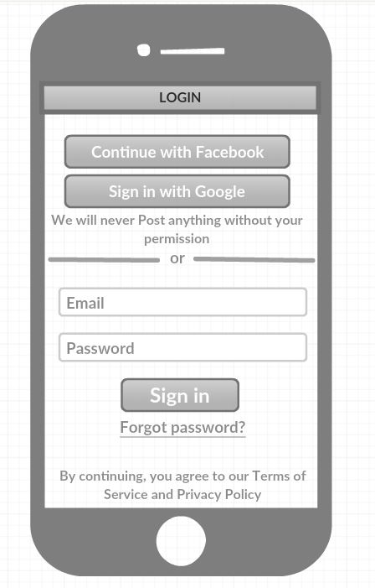

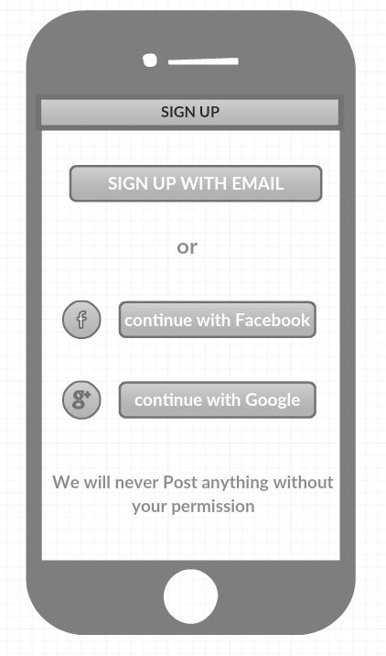

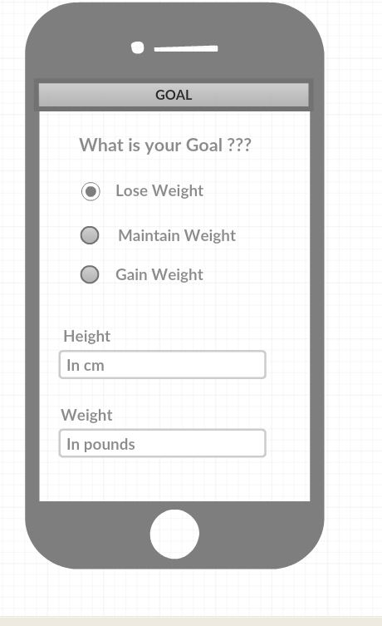

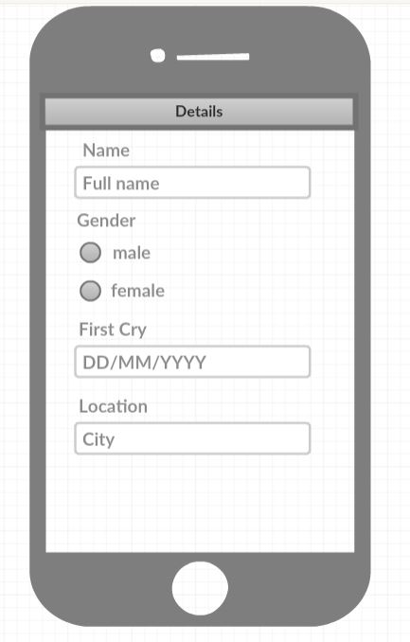

* + 1. **Architecture diagram/Sequence diagram/Class diagram/Use case diagram**

**Class diagram**

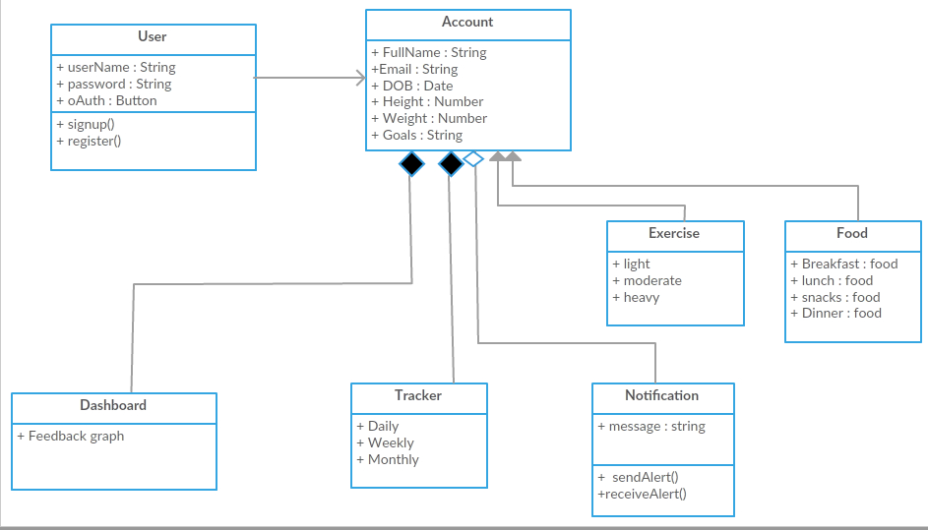

**Architecture diagram**

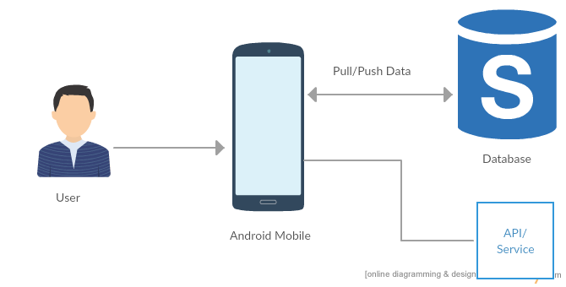

**Sequence Diagram**

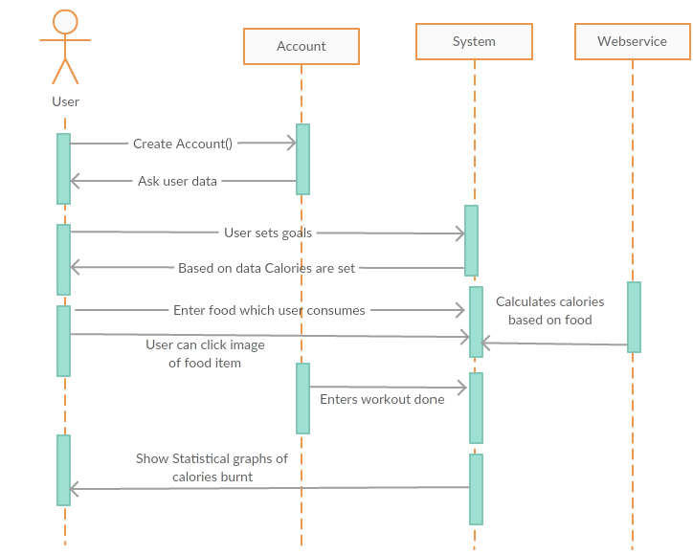

**Use case Diagram**

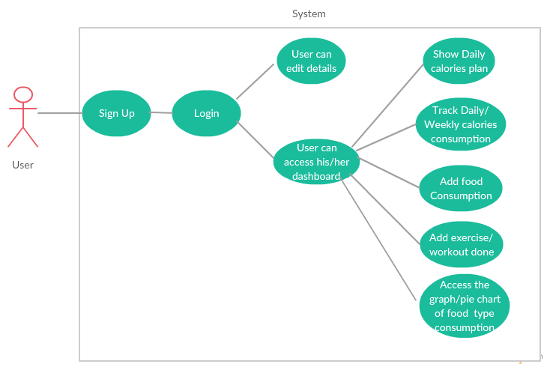

* 1. **Testing:**

**Unit test cases**



* 1. **Deployment**

**Main Page**

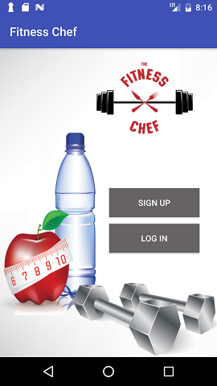

**Login Page**

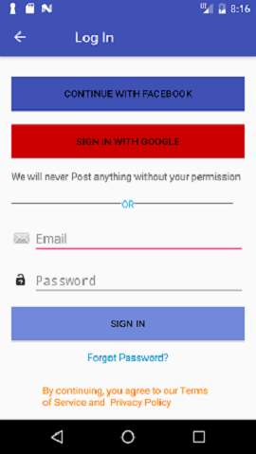

**Login Page validations**

* + - * **When user leaves the login fields empty**

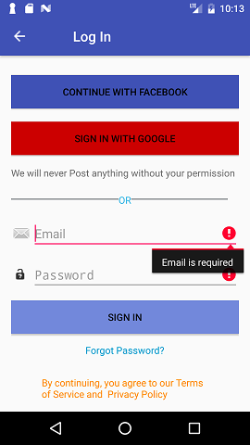

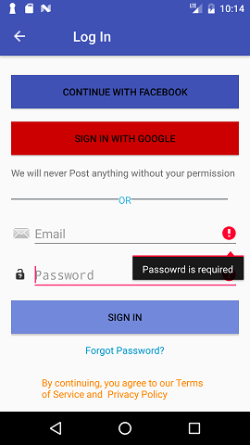

* + - * **When the email and password mismatches**

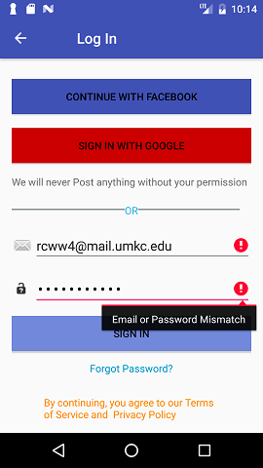

**Signup page**

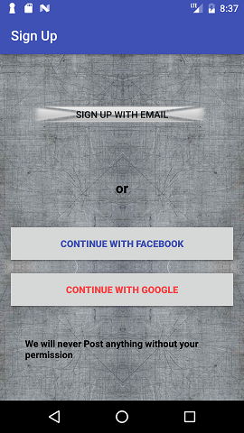

**Oauth Facebook**

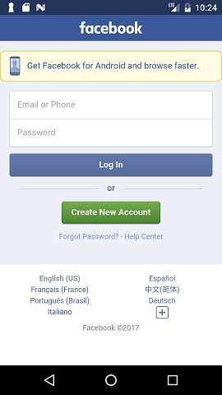 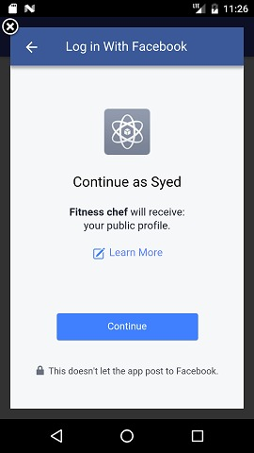

**Goal Page**

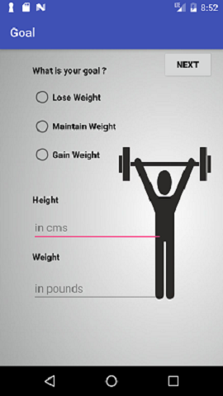

**Goal Page Validations:**

* + - * **When user leaves the fields empty**

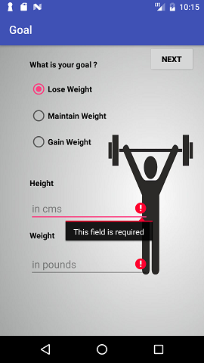

**Details page**

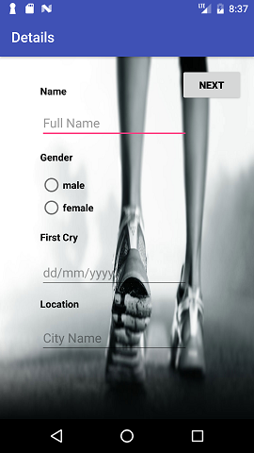

**4.4.2 Github Link**:

The below is the Link for the GitHub Repository in which the project documentation and source code and the project, its analysis in burndowns and Zen hub tools are also present

<https://github.com/DevenderSarda/Project-Fitness-Chef>

* 1. **Project Management**

**4.5.1 Implementation status report**

**4.5.1.1 Work completed**

**• Description**

* + - Fitness chef android application
    - Login and Registration Page
    - Design and working of tracking calories page

**• Responsibility & Time taken**

* Landing Page, Nageswara Rao Nandigam 2hr.
* Login Page, Nageswara Rao Nandigam 3hr.
* Sign UP page , Devender Sarda 3hrs.
* Goal Page, Syed Moin 2hrs.
* Details Page, Revanth 2 hrs.
* Wireframes, Revanth 1 hrs.
* Integrating Projects, Every individual 2hrs.
* Project Increment Report, Every individual 6hrs.
* UML diagrams, Syed & Nageswara Rao 5hrs.
* Unit testing & app logo Revanth & Dev 4 Hrs

**4.5.2.2 Contribution**

**4.5.1.2 Work to be completed**

* **Description**
  + Needs to Design body page
  + Working on Image scanner API
  + Needs to add few more features on dietary track
* **Responsibility**
  + Design body page -Revanth & Nageswara Rao
  + Image Scanner API - Devender & Moin
  + Dietary Track - Each individual

1. **Bibliography**

<https://developer.edamam.com/edamam-nutrition-api>  
<https://www.nutritionix.com/>

<https://developer.android.com/about/versions/nougat/index.html>

<https://material.io/icons/>

<https://developers.facebook.com/>